**NAME: MANI SAI MENDA**

**REG NO.:192111399**

**COURSE: DATABASE MANAGEMENT SYSTEMS FOR DATA ANALYTICS.**

**COURSE CODE: CSA0520.**

**Ex.No : 9**

**VIEW, INDEX, SEQUENCE**

**Question:**

**VIEW:**

1.Create a view with name ‘std_view’ using STUDENT table which holds the value of register number, name and DOB of student.

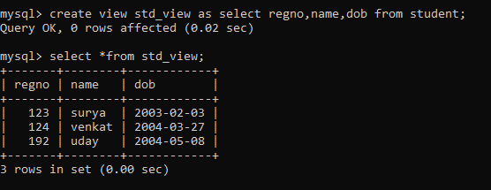

## INDEX:

2. create an index on courseno of student and analyze the performance

